

|  |  |  |
| --- | --- | --- |
| **QUANTITATIVE SCIENCES DEPARTMENT** | |  |
| **Course:** AMAA | |
| **Topic Title**: **Investigation 3 – Exploring trigonometric ratios** | |
| Student Name:_____________________________________ | Date: __________2015 | | |
| Special Instructions: Calculators Allowed, No Notes allowed | Time Allowed: 50 mins | | |
|  | Marks: / 46 | | |

**In-class investigation**

**Question 1 [3, 4, 5, 2, 2 : 16 marks]**

For the triangle drawn below (not necessarily to scale), the following trigonometric ratios apply for the angle at A.



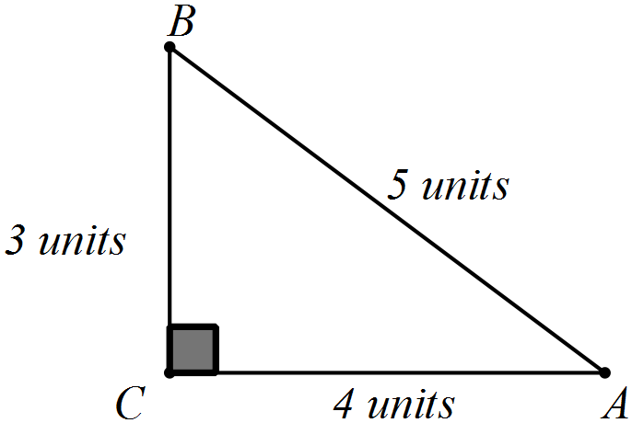

(a) Consider the sides of the triangle above are all doubled so that the triangle (not necessarily drawn to scale) can be represented by the diagram below.

Write statements, similar to those above, showing the unsimplified fractional and decimal values for the trigonometric ratios.

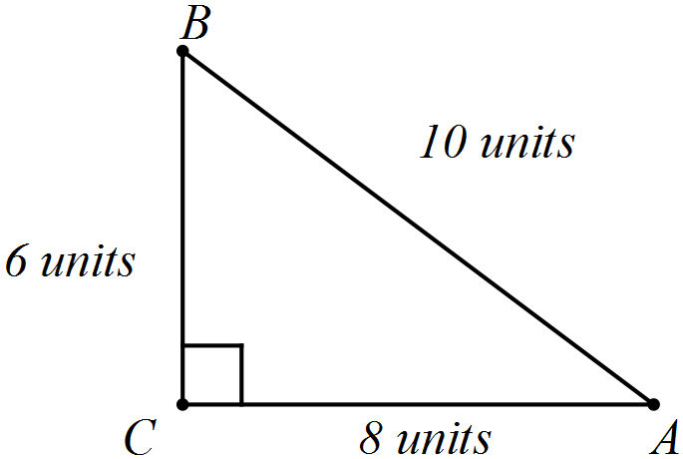

(b) Consider the sides of the first triangle given above are all tripled.

(i) Complete the number of units on the sides of the triangle below.

(ii) Write statements, similar to those above, showing the unsimplified fractional and decimal values for the trigonometric ratios.

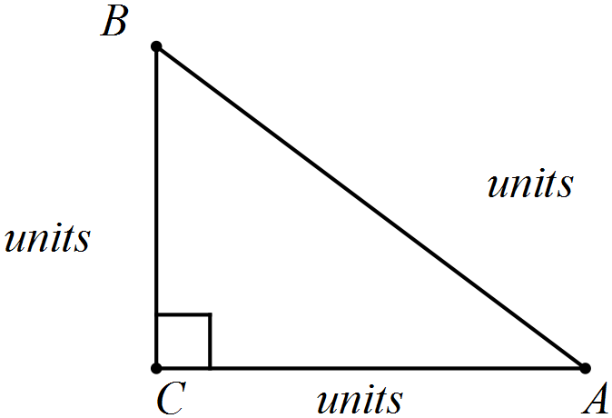

(c) Consider that the sides of the first triangle given previously are all multiplied by *k*.

(i) Complete the number of units on the sides of the triangle below.

(ii) Write statements, similar to those above, showing the unsimplified fractional and decimal values for the trigonometric ratios.

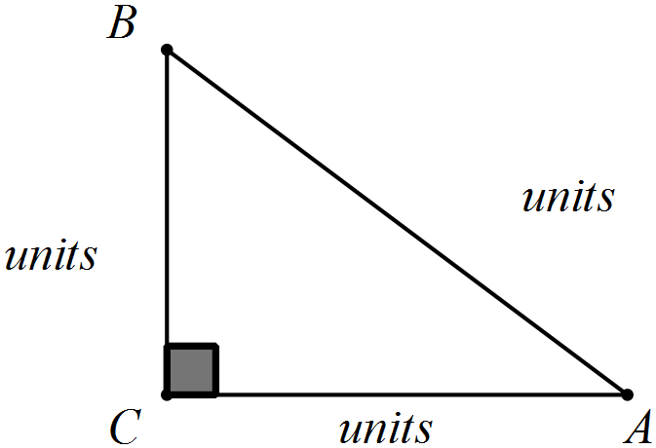

(d) Add your results from parts (a) to (c) to the table below.

|  |  |  |  |
| --- | --- | --- | --- |
| Part | Trigonometric ratio | Unsimplified fraction | Decimal |
|  |  |  | 0.6 |
|  |  | 0.8 |
|  |  | 0.75 |
| (a) |  |  |  |
|  |  |  |
|  |  |  |
| (b) |  |  |  |
|  |  |  |
|  |  |  |
| (c) |  |  |  |
|  |  |  |
|  |  |  |

(e) When all the sides of the triangle are multiplied by the same factor, what changes occur to

(i) the size of the angle at *A?*

(ii) the trigonometric ratios for the angle at *A?*

**Question 2 [3, 3, 4 : 10 marks]**

(a) Write down the trigonometric ratios as fractions for the angles at *M* and *Q*.



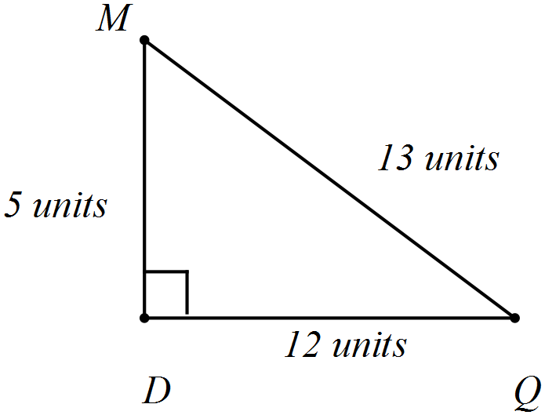

(b) What happens to these trigonometric ratios for the angles at *M* and *Q* when you multiply all the sides of the triangle above by a factor of 5? Explain how you arrived at your conclusion.

(c) Calculate the sides marked *x* in each of these triangles.

(i) (ii)

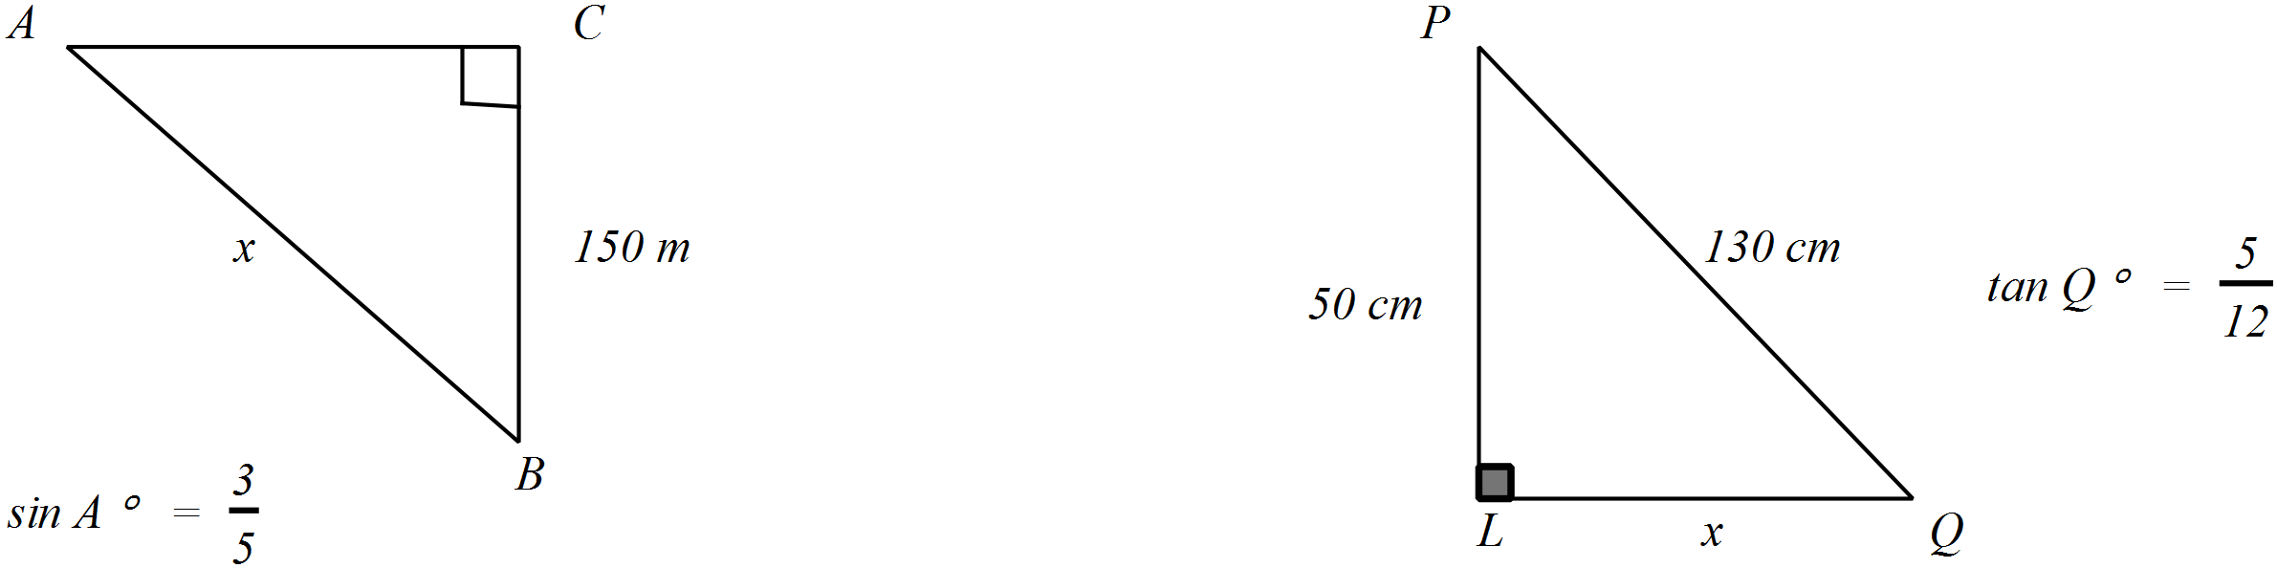

**Question 3 [1, 2, 2, 2, 2: 9 marks]**

Consider the question:

*If the length of one side of a triangle is doubled, is the size of the angle opposite it also doubled?*

(a) Determine the size of the angle opposite *CB*

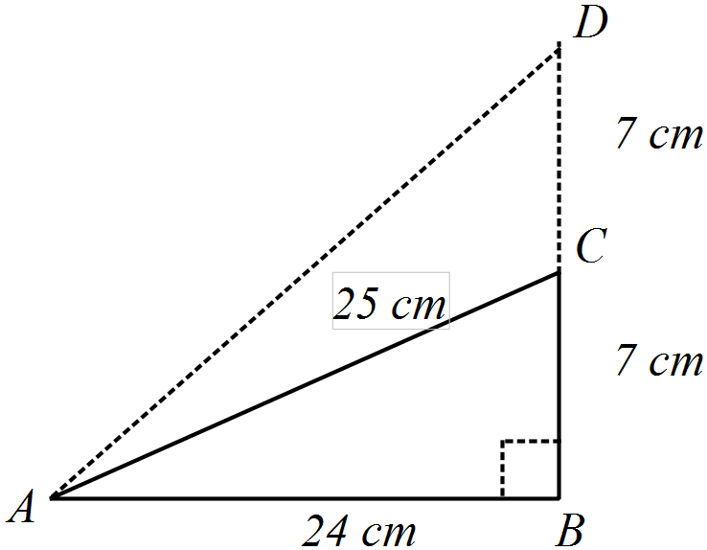



(b) Determine 

(c) (i) Determine 

(ii) Determine the size of 

(d) When the triangle was enlarged so that the side opposite A was doubled.

(i) was the tangent ratio of the angle at *A* () doubled?

(ii) was the size of the angle at *A* doubled?

(e) Is the following statement TRUE or FALSE?

*.* Justify your conclusion.

**Question 4 [6, 5 : 11 marks)**

The steps of a process to determine the length of the third side of a triangle are provided below.

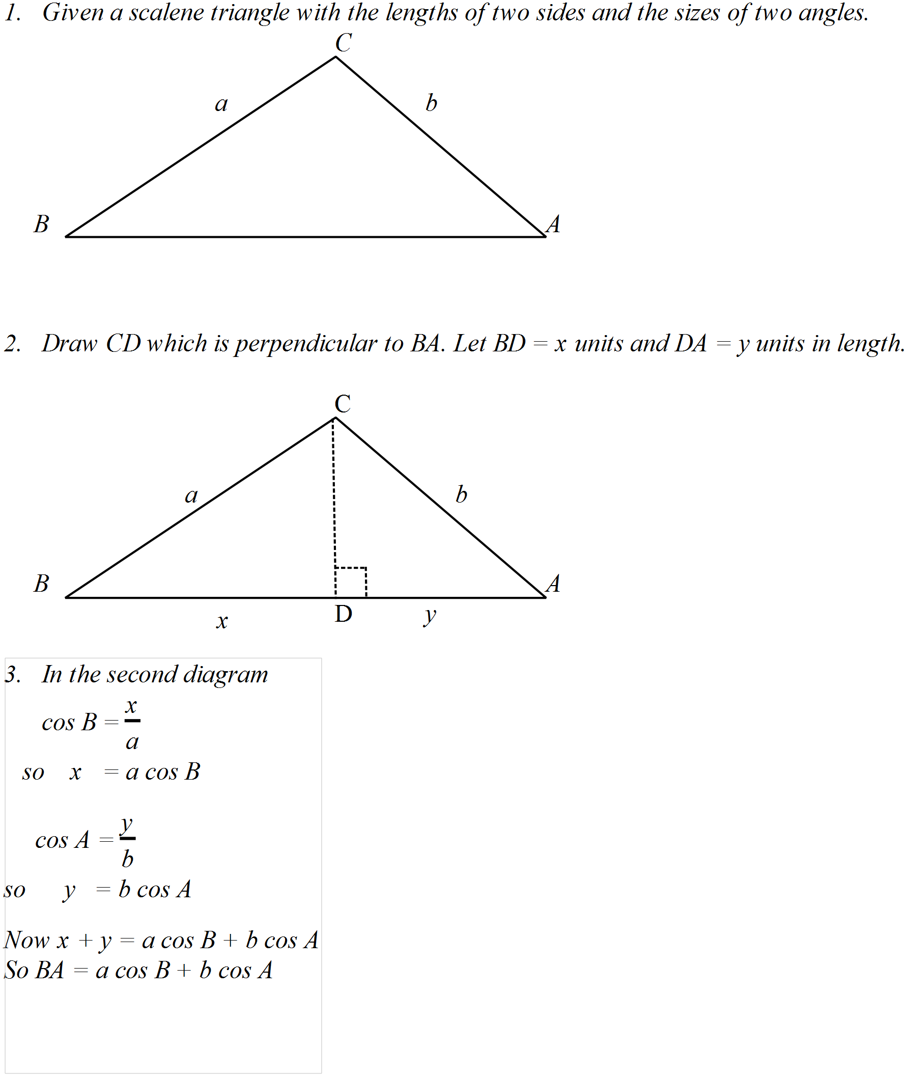

(a) Use the steps described on previous page to determine the length of the base of the triangle below.

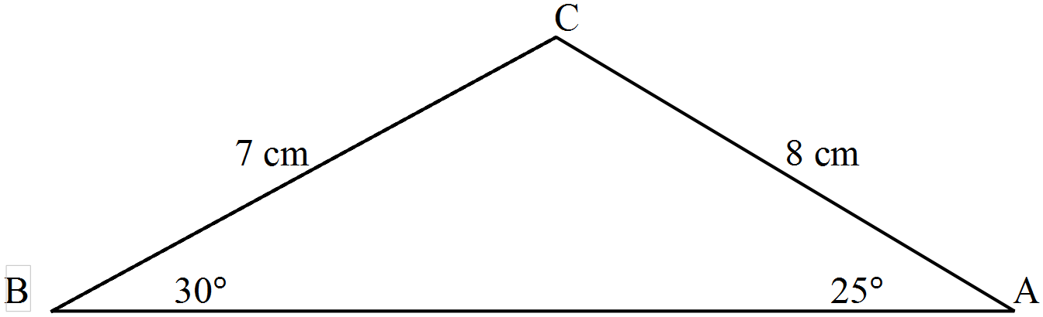

(b) Use the rule developed above [ *BA* = *a* cos *B* + *b* cos *A* ] to determine the length of the third side of each of these triangles.

(i)

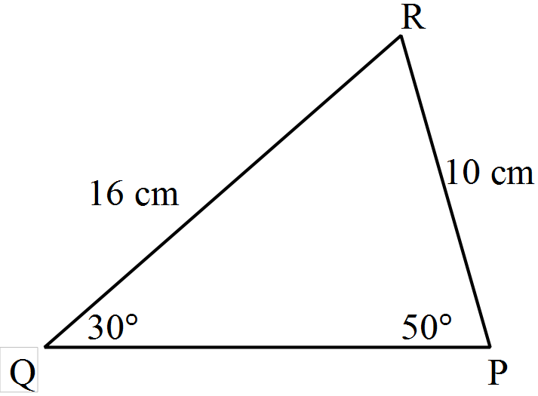

(ii)

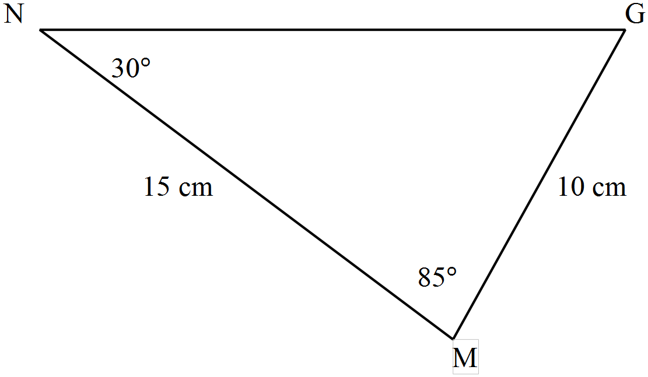

**End of questions**